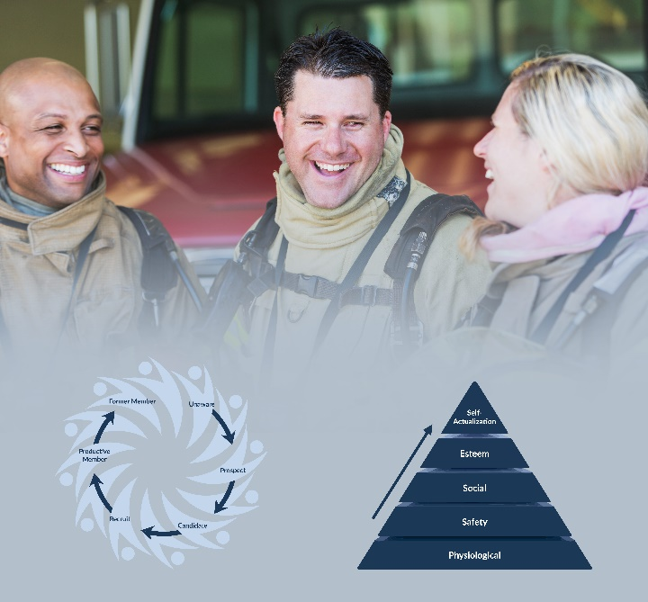

Recruitment and Retention Needs Assessment

Activity – Gather information
Use the sections below to capture what you know about:
- Your department’s roles, tasks, and staffing needs
- Any existing marketing material for your department

Needs Analysis
Use this worksheet to draft or refine the needs assessment for your department. Feel free to remove any Job Groups, Roles, or Tasks that don’t apply to your department.
Step 1: In Column A, enter the number of people needed to accomplish the job in that row.
Step 2: In Column B, enter the number of people you currently have in those roles
Step 3: Subtract Column B from Column A. This will tell you how many people are needed to complete that job group.
Step 4: In Column D, enter the number of people who are in training now, but are not yet qualified for the job. For example, if you have two people in the fire academy, they would be considered “Soon-to-be-Qualified Members.”
Step 5: Subtract Column D from Column C. This will tell you how many people your department needs to recruit in that job group.
Step 6: At the bottom of the chart, add up the totals in Column E to tell you how many people your department needs to recruit overall.
Note: There should only be one number in each square. In most departments, people perform multiple roles. Because of that, as well as many other factors, this chart is not meant to be precise, but to give a high-level view of the staffing needs of your department.
Job Group | Role / Tasks | A) Staff Needed to Complete Tasks | B) Current Staff | C) Staffing Needs (C=A-B) | D) Soon-to-be-Qualified Members | E) Recruiting Needs  (E=C-D)
Strategic-Level Operations | Chief & Deputy Chief
Strategic-Level Operations | Assistant Chiefs
Operations Leadership | Captains
Operations Leadership | Lieutenants
Operations Leadership | Safety Officers
Operations | Driver/Operators
Operations | Firefighters (Interior Qualified)
Operations | Medical Personnel (EMTs, Medics, etc.)
Operations | Training Officer, Pre-Planning
Operations Support | Equipment ordering
Operations Support | Equipment maintenance
Operations Support | Apparatus maintenance
Operations Support | Station maintenance
Administrative Leadership | President, Vice President, Secretary, etc.
Administrative Financial | Treasurer, Financial Secretary
Administrative Support | Fire Administrative Officer, Bookkeeper, etc.
Administrative Support | Fundraising, auditing
Membership/Recruitment & Retention/Marketing /Incentives | Recruiting new volunteers/members, interviewing, vetting, onboarding new members
Membership/Recruitment & Retention/Marketing /Incentives | Creating/producing marketing materials
Membership/Recruitment & Retention/Marketing /Incentives | Creation and management of incentive programs
Other:
Other:
Other:
Other:
Other:
Other:
Other:
Other:
Other:
Other: |  |  |  |  | TOTAL:

